ServiceNow – High Impact Incident Control
UI Policy + Client Scripts + Testing Guide
This guide explains the configuration in a simple order. The setup applies extra controls when an Incident has Impact = High, automatically sets Urgency to High, requires Assigned To, and prevents State changes from the list view.

1. Create the UI Policy
- Go to System UI → UI Policies and click New.
- Set Name to High Impact Control.
- Select Table = Incident [incident] and keep Active checked.
- Set the condition to Impact is 1 – High.
- Add a UI Policy Action for Assignment group and make it Mandatory.
- Keep Reverse if false enabled so the policy effect is reversed when Impact is no longer High.
- Submit the UI Policy.
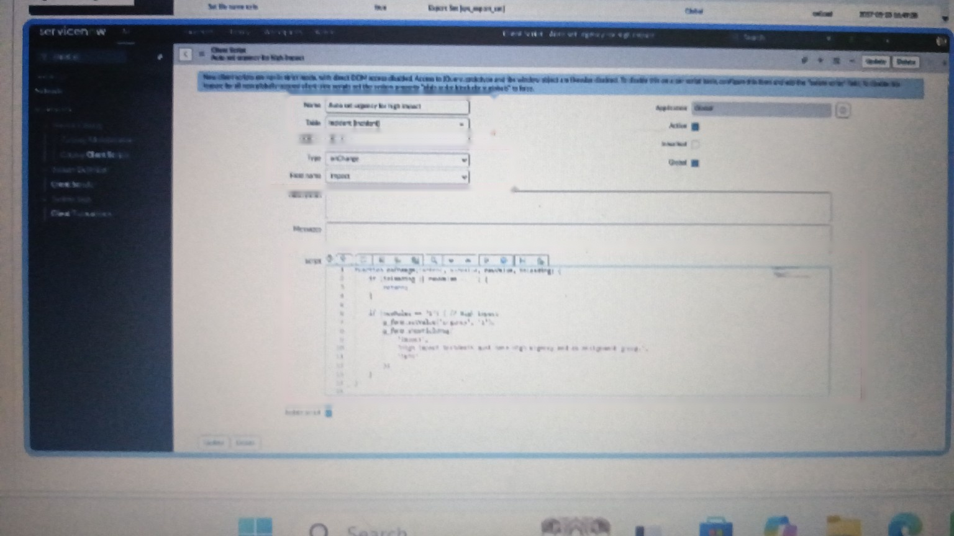
UI Policy configuration

2. Make Urgency Read-only for High Impact
- Open the High Impact Control policy and go to its UI Policy Actions.
- Click New and select Field name = Urgency.
- Check Read-only. Leave Visible unchanged.
- Submit the action.
- When Impact is High, Urgency will be visible but users cannot manually change it.

3. Client Script – Automatically Set Urgency
- Go to System UI → Client Scripts and click New.
- Name: Auto set urgency for high impact
- Table: Incident
- Type: onChange
- Field name: Impact
- Active: checked
- Paste this script:
function onChange(control, oldValue, newValue, isLoading) {
if (isLoading || newValue == '') {
return;
}
if (newValue == '1') {
g_form.setValue('urgency', '1');
g_form.addInfoMessage(
'Urgency set to High for High impact incident.'
);
}
}
- Submit the Client Script.
- Test it by changing Impact to High. Urgency should automatically become High.
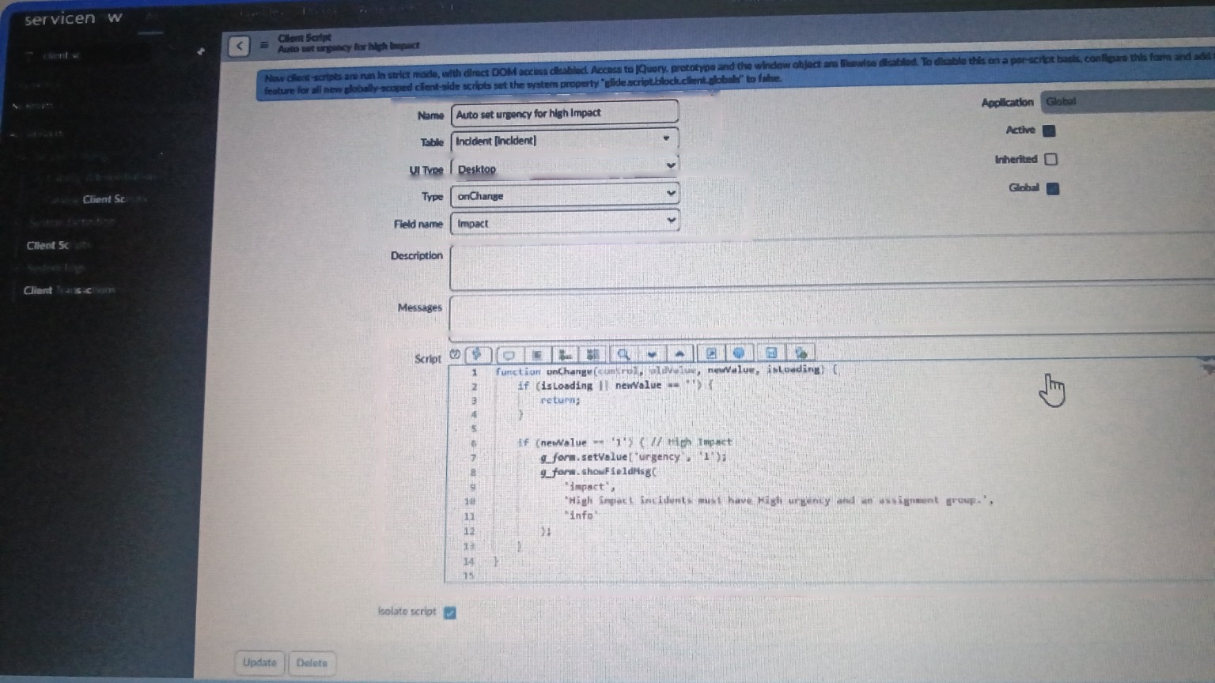
Client Script for automatically setting Urgency

4. Client Script – Prevent Save if Assigned To is Empty
- Create another Client Script.
- Name: Prevent save if assigned to missing
- Table: Incident
- Type: onSubmit
- Active: checked
- Paste this script:
function onSubmit() {
if (g_form.getValue('impact') == '1' &&
g_form.getValue('assigned_to') == '') {
g_form.showErrorBox(
'assigned_to',
'Assigned To is mandatory for High impact incidents.'
);
return false;
}
return true;
}
- Submit the script.
- Test by setting Impact to High, leaving Assigned To empty, and clicking Submit. The Incident should not save.
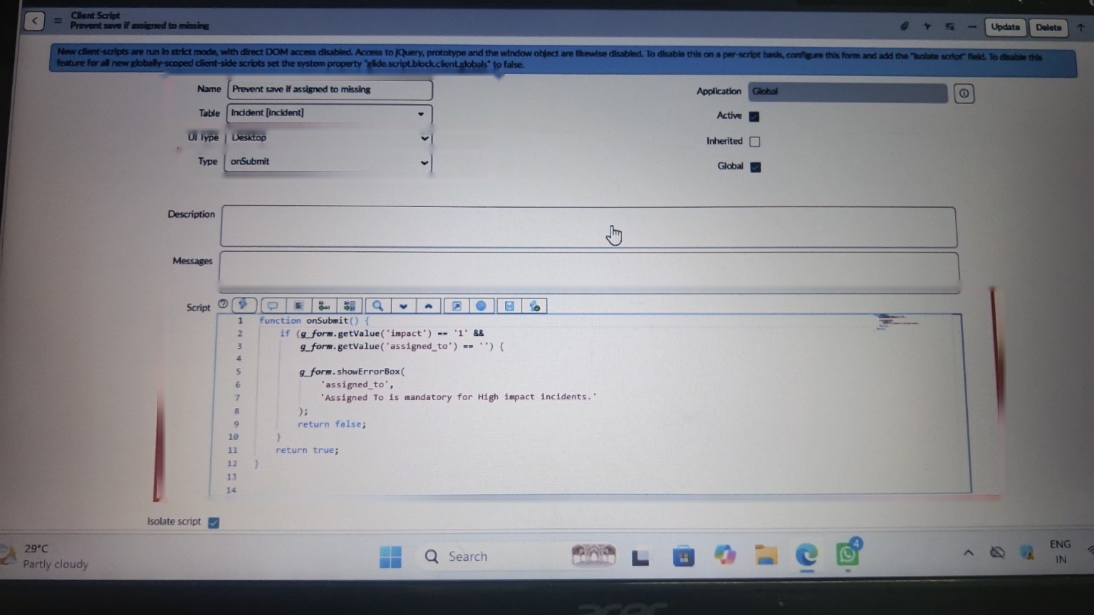
onSubmit Client Script

5. Client Script – Block State Changes from List Editing
- Create another Client Script.
- Name: Prevent state change via list edit
- Table: Incident
- Type: onCellEdit
- Field name: State
- Active: checked
- Paste this script:
function onCellEdit(sysIDs, table, oldValues, newValue, callback) {
alert('State cannot be updated using list editing. Please open the Incident.');
callback(false);
}
- Submit the script.
- Open the Incident list and try changing State directly in the list. The change should be blocked.
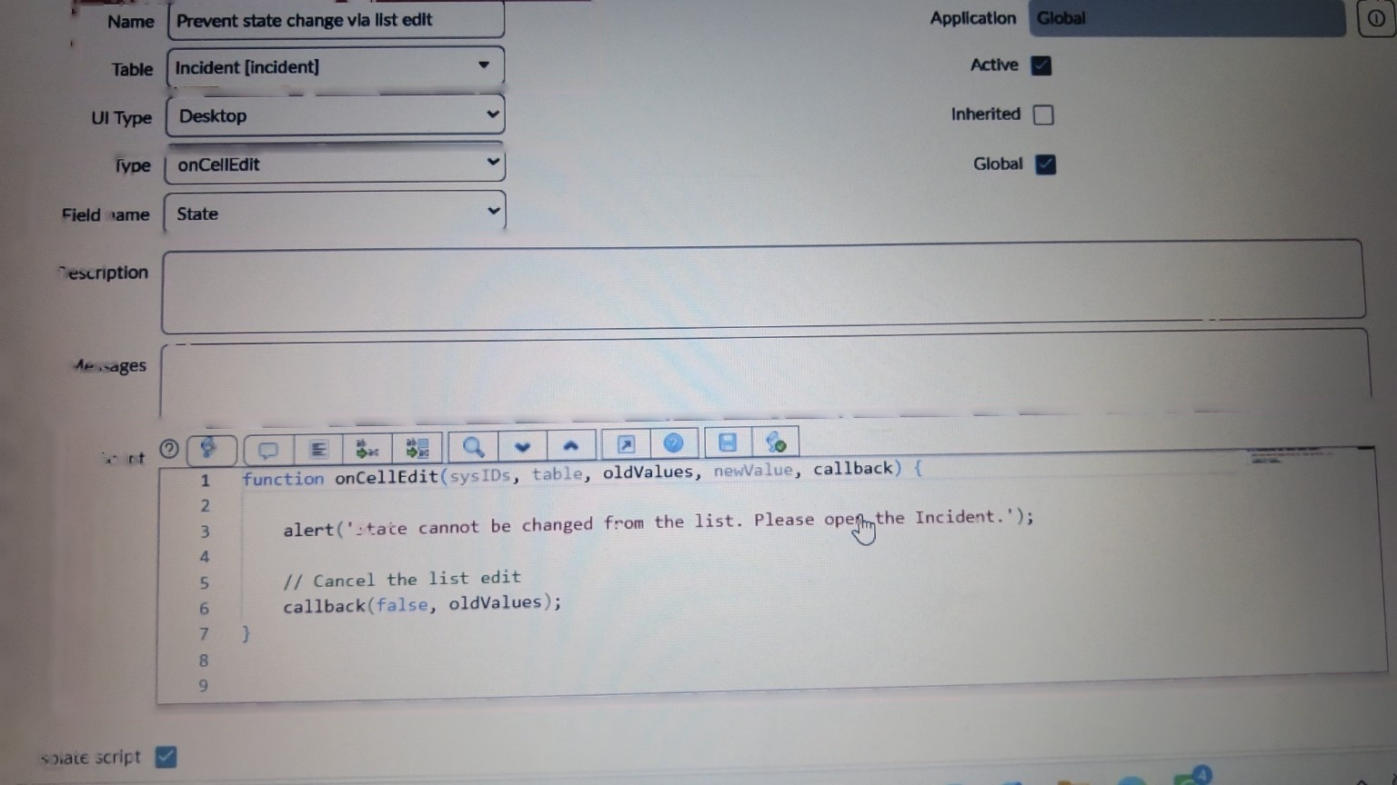
onCellEdit Client Script

6. Test the Complete Setup
- Go to Incident → Create New.
- Set Impact to 1 – High.
- Leave Assigned To empty and click Submit.
- The Incident should not be saved.
- An error should say that Assigned To is mandatory for High impact incidents.
- Urgency should automatically become 1 – High.
- Urgency should be read-only while Impact remains High.
- Select a user in Assigned To and submit again.
- The Incident should save successfully.
- Open the Incident list and try editing State directly.
- The list edit should be cancelled and the warning message should appear.
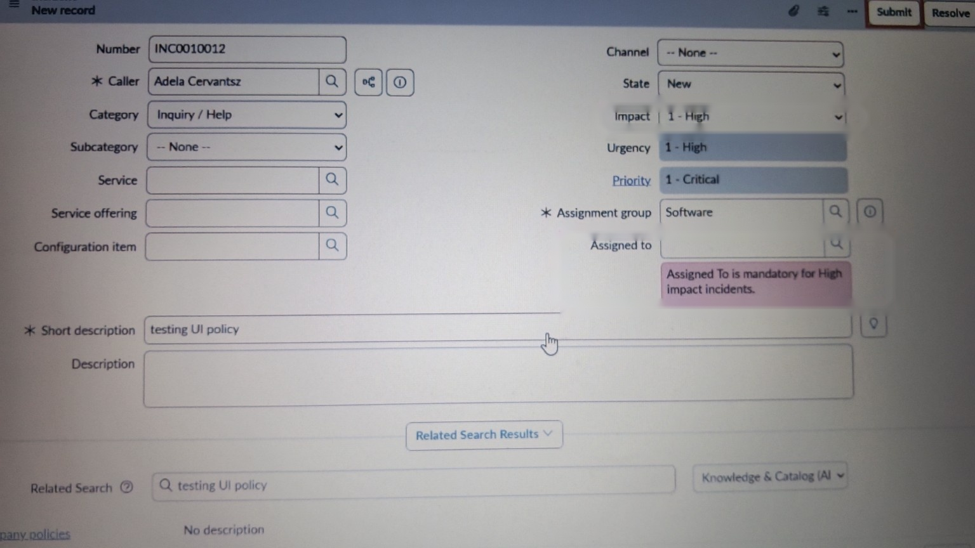
Test result: Assigned To required for High Impact
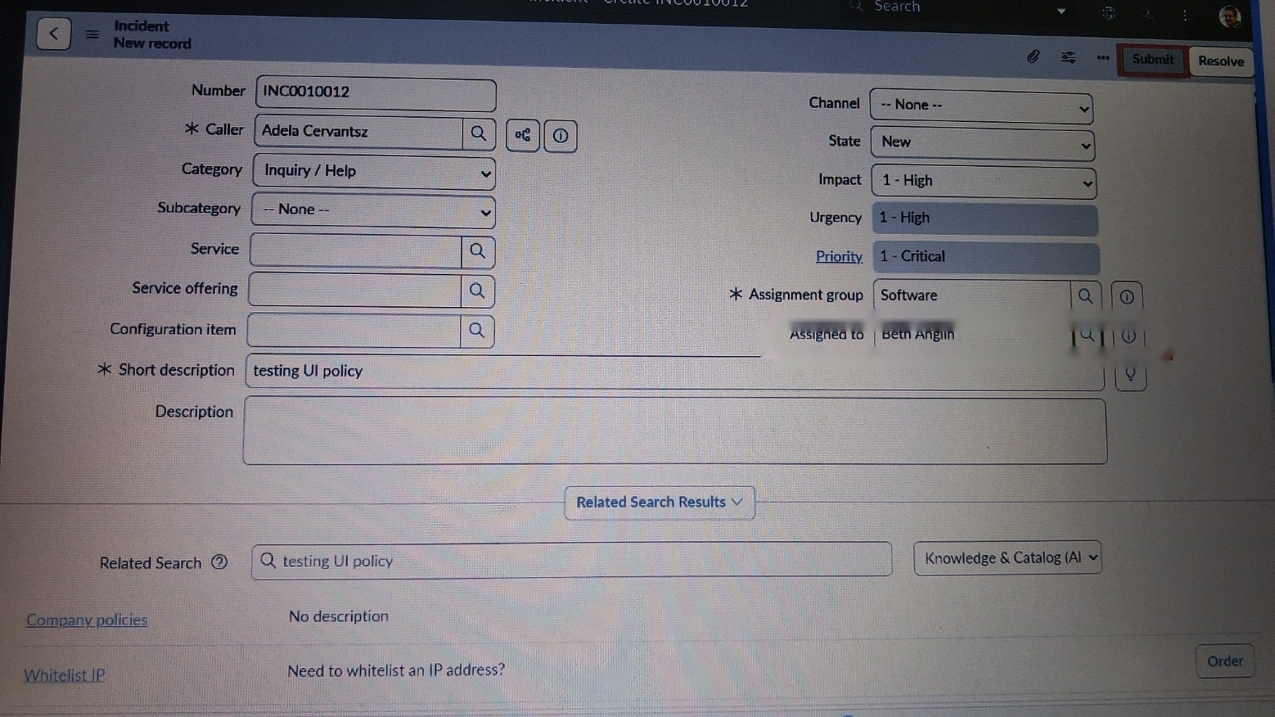
Test result: Assigned To filled

7. Expected Result
- Impact = High activates the High Impact Control.
- Urgency is automatically set to High.
- Urgency becomes read-only while the condition is true.
- Assignment group is mandatory under the configured UI Policy Action.
- Assigned To cannot be left empty when Impact is High.
- State cannot be changed directly through list editing.
- When the condition becomes false, the configured UI Policy effects are reversed.
End of Guide

